**Standard Reporting Procedures (SRP) for the National Clinical Audit and Patient Outcomes Programme (NCAPOP)**

**HQIP Standard Reporting Procedure (SRP) for NCAPOP\***

**\*National Clinical Audit and Patient Outcomes Programme**

**Last updated: 10 November 2014**

**Introduction:**

HQIP commission the NCAPOP on behalf of NHS England and the Welsh Government, and for some projects the Scottish Government, Northern Ireland Government, the Isle of Man, Jersey and Guernsey. These groups are referred to collectively as ‘funding bodies’ in this document. For the purposes of this document ‘provider’ refers to the team that runs the national clinical audit or clinical outcome review programme.

The Standard Reporting Procedure outlines the processes and timescales for publishing public reports, submitting data to the Data.gov.uk website and the processes governing the presentation or publication of data in other formats.

Contents

1. Review and approval of public reports 1

2. Making data available on data.gov.uk 3

3. Including unpublished data in presentations or journal articles 3

# Review and approval of public reports

HQIP is required to co-ordinate a review and approval process between HQIP and the funding bodies prior to the publication of NCAPOP reports. This process enables HQIP to support audit providers in ensuring their key messages can support service providers, service users, clinicians and commissioners drive quality improvement in patient care and outcomes. In addition it allows funding bodies an opportunity to prepare for the key messages in the report.

During the review stage, HQIP or the funding bodies may seek further clarification or information from the project team. You should not proceed with any publication without confirmation of approval by HQIP.

**Note:**

All national and provider-level reports produced by NCAPOP projects from 2012 onwards should be available in the public domain. The only exceptions are reports containing the results of development/piloting or where small case numbers might make patients identifiable.

The table below explains the process and timelines for the review and approval of public reports.

**Review and approval process and publication proposed timelines**

*Please note a separate request is required for each individual report.*

**Name of Project: Name of Project Report:**

**Reporting Period:**

**Geographical Coverage:**

|  |  |  |
| --- | --- | --- |
| **TIME** | **ACTIVITY / GUIDANCE** | **PROPOSED DATE** |
| **6 months prior to report publication** | * The provider should contact their designated HQIP project manager to discuss the proposed timetable for the publication of the report and related publicity materials including press release. * Within the following week, the provider should complete the right hand column with the relevant dates   If alterations to the agreed timetable become necessary, please contact your HQIP project manager immediately to discuss. Any agreed changes must be confirmed in writing. Changes to the timetable at short notice are difficult to accommodate and may not be approved.  Prior to the 2 month submission, the HQIP project manager and provider will agree a date for an early draft report to be reviewed by the HQIP project manager and HQIP senior sponsor. | (dd/mm/yyyy) |
| **2 months prior to report publication** | * The provider will email the following to their HQIP project manager:   + the draft report   + the draft press release * Your HQIP project manager will co-ordinate the review and collate comments from the HQIP communications department, representatives of the funding bodies and others as agreed (e.g. Independent Advisory Group members). | (dd/mm/yyyy) |
| **1 month prior to report publication** | * The HQIP project manager will return any requests for clarification to the provider.The provider then has one month to work on the final design and printing. * The provider should submit to their HQIP project manager responses to comments where changes or further clarification have been requested. The HQIP project manager will make these responses available to funding bodies and liaise between both parties as required. | (dd/mm/yyyy) |
| **5 working days prior to publication** | * The provider will submit to HQIP one hard copy and one electronic copy of the final report (pdf), and the final press release to the HQIP project manager * The provider or provider communications lead informs the HQIP communications team (communications@hqip.org.uk) of final media plan copying in the HQIP project manager. HQIP to be included on media distribution list. | (dd/mm/yyyy) |
| **Publication day** | * Date of publication of report * HQIP will publish the report and news story on [www.hqip.org.uk](http://www.hqip.org.uk) by 10am * HQIP will update social media including twitter and facebook by 10am | (dd/mm/yyyy) |

# Making data available on data.gov.uk

Data from NCAPOP audits should be available for use without license or restriction on data.gov.uk to support its use by patients, the public, researchers, and healthcare professions. All NCAPOP audits must publish the data contained in their annual reports on data.gov.uk, either on the day of the report publication or as soon as possible after.

In order to make the audit data accessible, audit suppliers need to sign up for an account via the website and request to be registered as an editor under the entity of HQIP. Once registered, please email HQIP your user name so that permission can be given.

Guidance for submitting data on data.gov.uk can be found here: <http://hqip.org.uk/national-programmes/a-z-of-nca/audits-and-data-gov-uk/>

# Including unpublished data in presentations or journal articles

* If you wish to present data that has already been published in a report, you do not need to ask permission or notify HQIP.
* If you are publishing a journal article using data that has already been published, you do not need to ask permission, but please send your HQIP project manager a copy when it has been accepted.

In most cases it is expected that relevant public audit reports will precede journal articles, with articles then going on to explore key themes in greater depth for specific professional audiences. The following processes apply only to the use of unpublished NCAPOP data by any member of the audit provider team (e.g. presentation at specialist society meetings or inclusion in journal publications). Please see– **Process Chart below for details**.

**Requests from members external to the audit provider team**

If there is a request is for someone external to the audit team to

• present unpublished data; or

• access the project dataset for data that has already been published,

the HQIP data access process should be followed.

The HQIP data access process and forms can be found on our website at: <http://www.hqip.org.uk/national-clinical-audit-and-patient-outcomes-programme-data-access-request-process/>

**Process Chart for Including Unpublished Data in Presentations and Journal Articles[1]**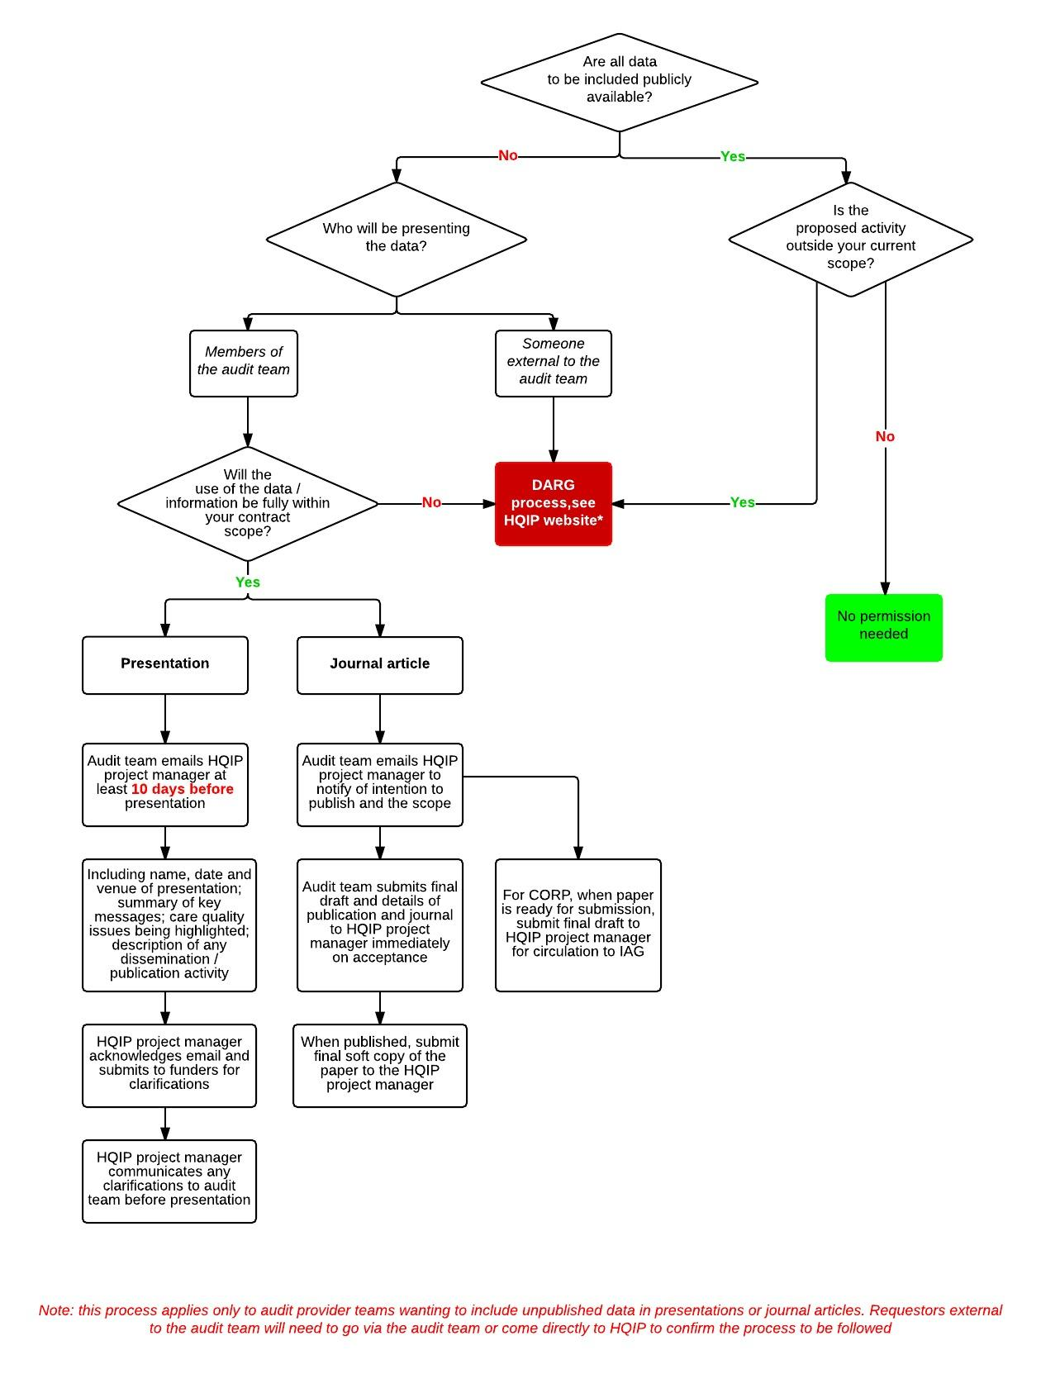

1. *HQIP DARG process: http://www.hqip.org.uk/national-clinical-audit-and-patient-outcomes-programme-data-access-request-process/